Electric Vehicles Market Size Analysis

## Process Overview

Market size analysis for electric vehicles (EVs) involves several key steps:

## **Define Market Scope**: Determine whether the analysis is global, regional, or country-specific.

## **Data Collection**: Gather data from industry associations, market research firms (e.g., BloombergNEF, IEA), and government publications.

## **Data Preparation**: Clean and preprocess the data for thorough analysis.

## **Analytical Modeling**: Utilize historical data to identify trends and forecast future market sizes.

## **Visualization and Reporting**: Present findings through compelling visualizations and strategic recommendations.

## Step-by-Step Analysis

* Importing Necessary Libraries and Loading Data - Begin by importing essential libraries such as pandas, matplotlib, seaborn, numpy, and the curve fit function from scipy.optimize. Load the dataset to start the analysis.
* Data Cleaning - Ensure the dataset is clean by handling missing values and verifying appropriate data types. This step is crucial for accurate analysis.
* Analysis Areas:
  + EV Adoption Over Time: Analyze how the number of EVs has increased each model year.
  + Geographical Distribution: Determine the countries and cities where EV registrations are highest.
  + EV Types: Dataset breakdown according to kind of electric vehicle (BEV, etc.).
  + Make and Model Popularity: List the most popular models and makes among the EVs that are registered.
  + Electric Range Analysis: Analyze the electric range of vehicles to gauge the advancement of EV technology.
  + Estimated Market Growth: Perform an analysis to determine the estimated growth for the electric vehicle market.

### EV Adoption Over Time

Visualize the number of EVs registered by model year to understand adoption trends.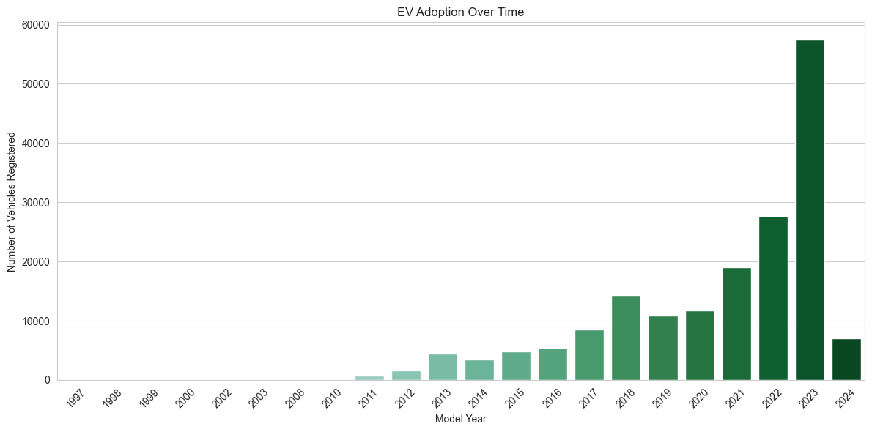

* **Insight:** The bar chart clearly shows that EV adoption has steadily increased over time, with a significant upward trend starting around 2016. From 2017 onwards, the number of registered EVs accelerates rapidly. Notably, 2023 marks a peak in EV adoption, with the highest number of registrations recorded.

### Geographical Distribution

Analyze the distribution of EV registrations across top counties and cities.

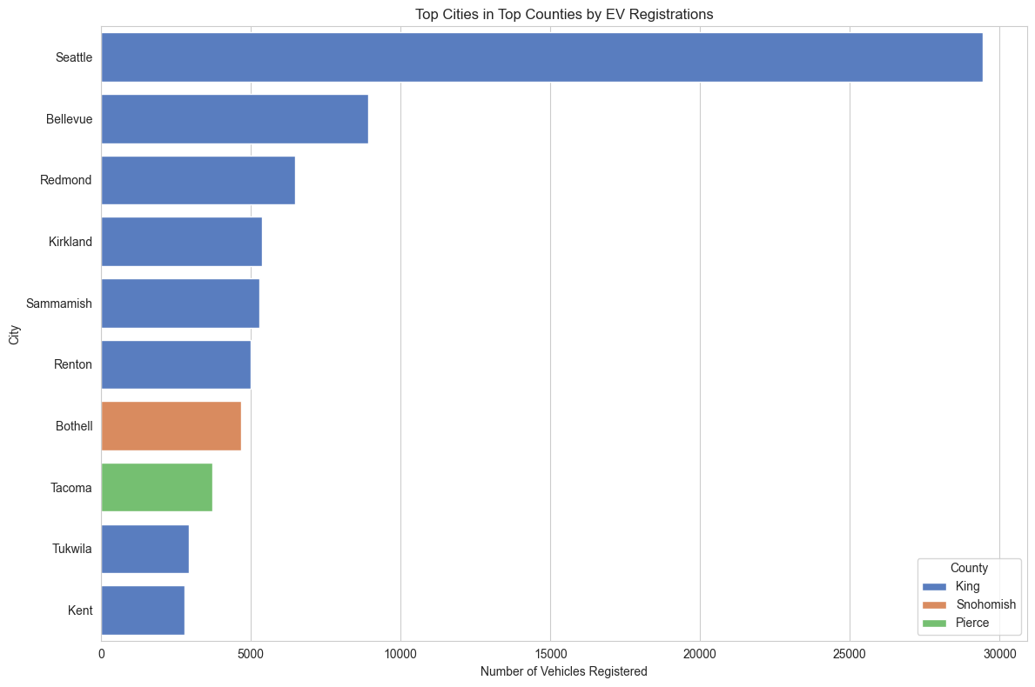

* **Insight**: The graph comparing EV registrations in King, Snohomish, and Pierce counties reveals that EV adoption is concentrated in certain areas, particularly in King County. This uneven distribution highlights potential markets for targeted EV infrastructure development.

### Types of Electric Vehicles

Examine the popularity of different types of electric vehicles.

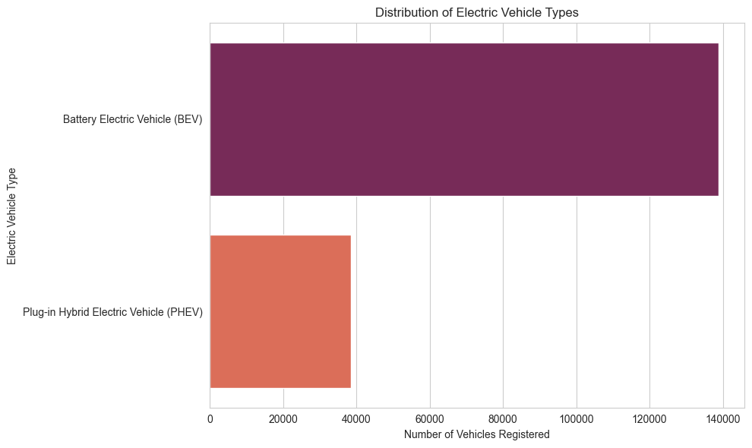

* **Insight:** Battery Electric Vehicles (BEVs) dominate the market, being more common and favored than Plug-in Hybrid Electric Vehicles (PHEVs). This trend underscores the growing consumer preference for fully electric options.

### Make and Model Popularity

Identify the most popular EV makes and models.

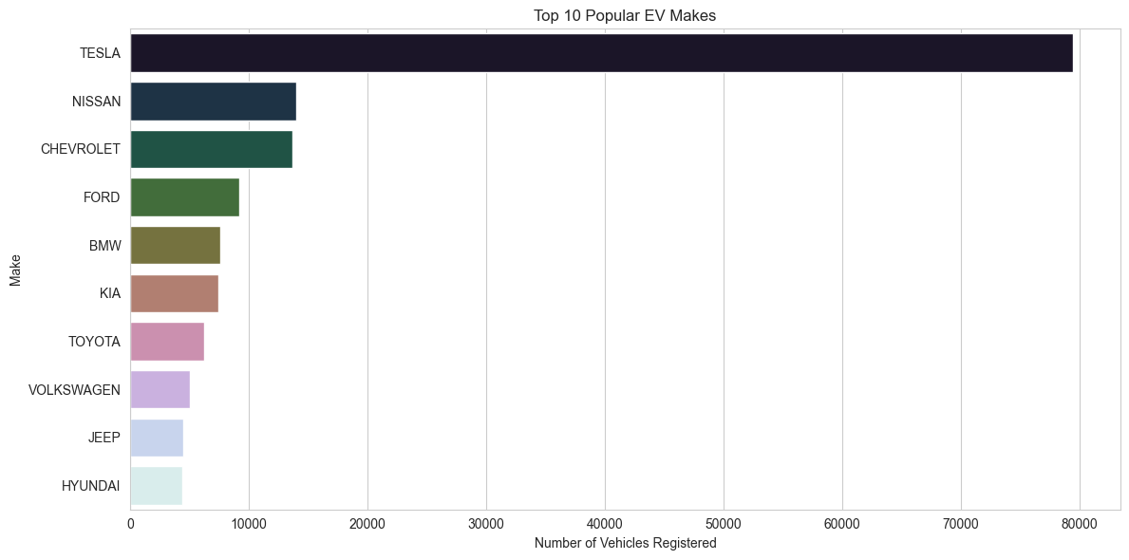

* **Insight:** Tesla leads the market with the largest number of registered vehicles, significantly outpacing competitors like Nissan and Chevrolet. Within Tesla's lineup, the Model Y and Model 3 are the most registered, followed by the Model S and Model X. Nissan's LEAF and Chevrolet's Bolt EV also have notable registrations, indicating strong competition in certain segments.

Most Popular Models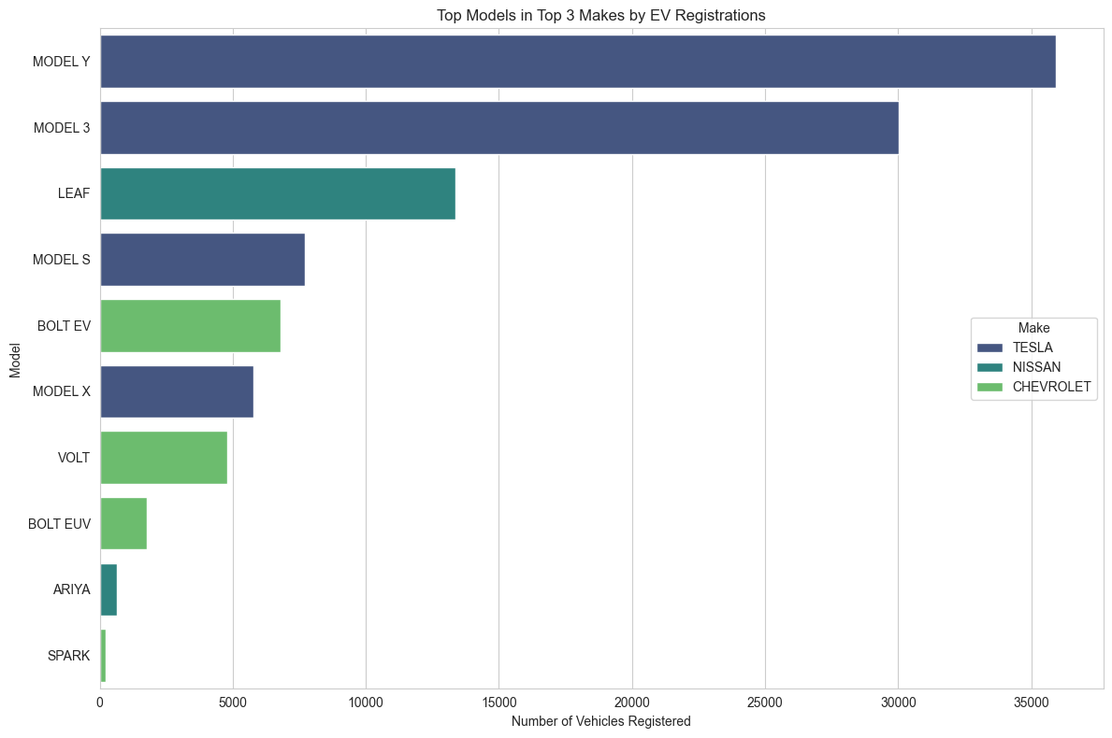

The graph above shows the distribution of electric car registrations across the top three manufacturers: Tesla, Nissan, and Chevrolet. Here are the results:

* The most registered vehicles are TESLA's MODEL Y and MODEL 3, with MODEL Y having the most registrations.
* The Nissan LEAF is the third most popular model and the most registered non-TESLA vehicle.
* TESLA's MODEL S and MODEL X have a large number of registrations.
* CHEVROLET's BOLT EV and VOLT are next in the rankings, with significant registrations, followed by the BOLT EUV.
* NISSAN's ARIYA and CHEVROLET's SPARK have the fewest registrations among the vehicles presented.

### Electric Range Analysis

Analyze the electric range of vehicles to gauge battery technological advancements.

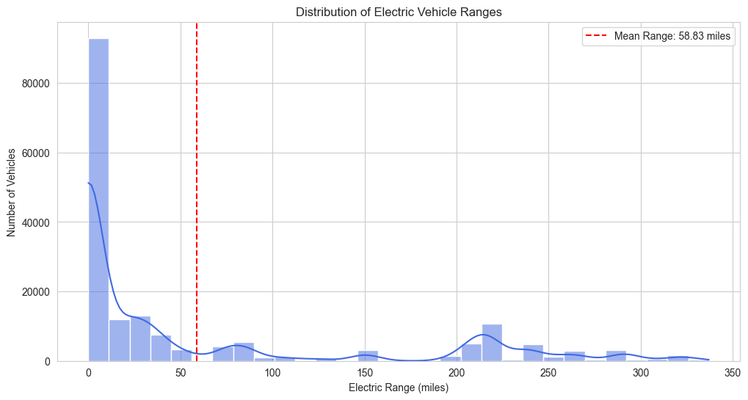

* **Insight:** The graph shows a high concentration of vehicles with a low electric range, peaking just before 50 miles. Although there are vehicles with ranges up to 350 miles, the majority have a lower range. The average electric range stands at approximately 58.84 miles, indicating room for improvement despite advancements.

### Trend of Electric Ranges over Model Years

Examine how advancements in battery technology and vehicle design have influenced electric range capabilities over time.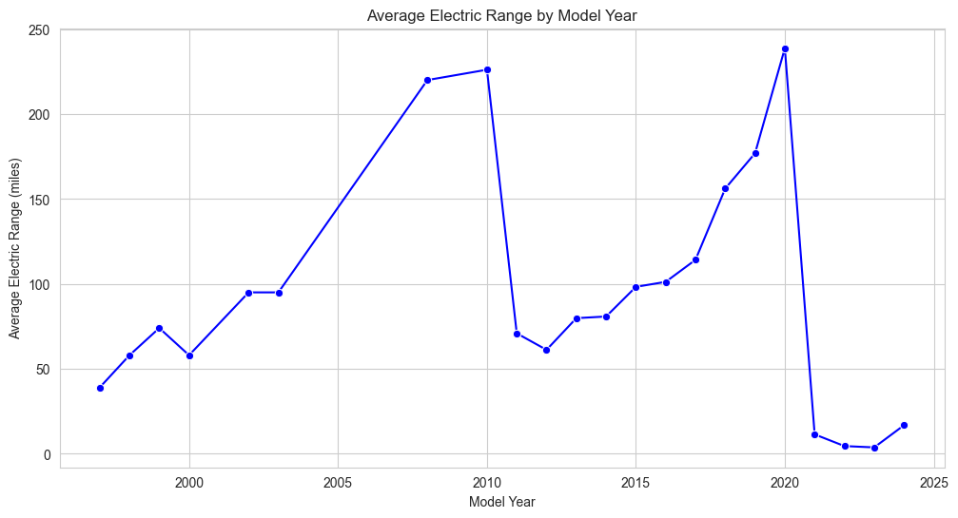

* **Insight:** The average range of EVs has generally increased, peaking around 2020. Despite a subsequent drop, likely due to the introduction of more lower-range models or incomplete data, there is a slight recovery in recent years. This trend reflects ongoing improvements in battery technology and vehicle efficiency.

### Electric Ranges Among Top Manufactures and Models

Compare the electric ranges among leading manufacturers and models.

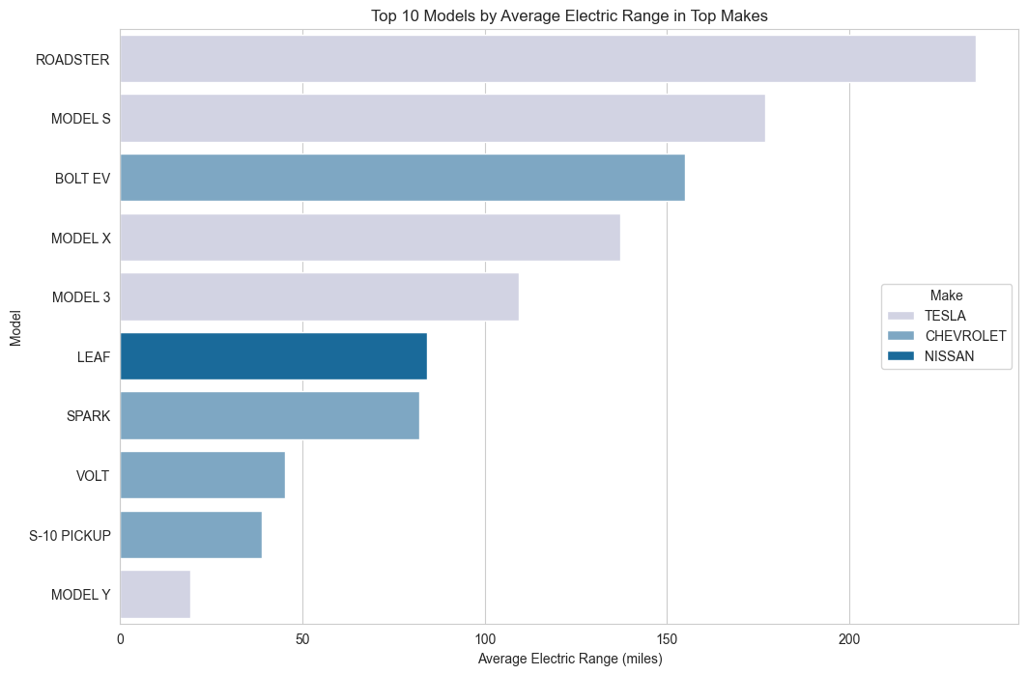

* **Insight:** Tesla's models, particularly the Roadster, Model S, Model X, and Model 3, exhibit the highest average electric ranges, highlighting Tesla's leadership in range capability. Chevrolet's Bolt EV also stands out with a significant range, while Nissan's LEAF and Chevrolet's Spark have more modest ranges.

### Estimated Market Size Data

Evaluate the growth trajectory of EV registrations.

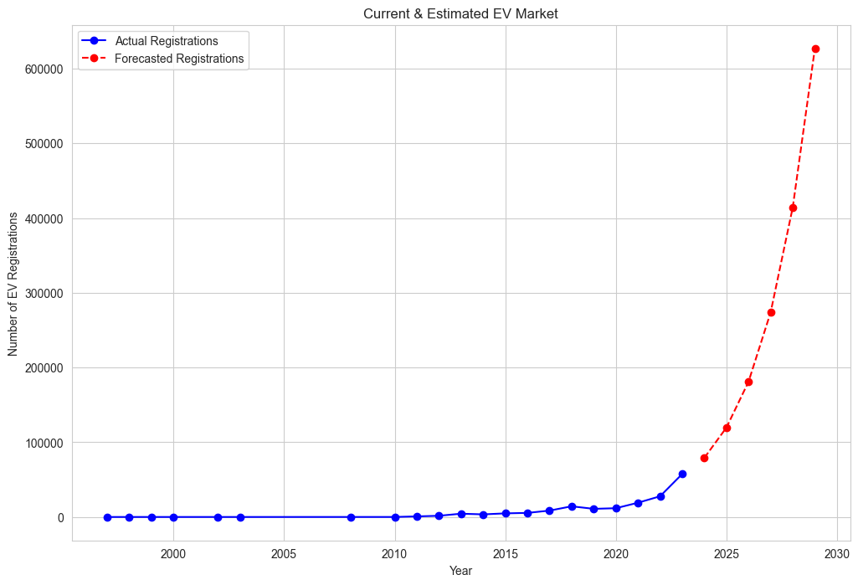

* **Insight:** Real EV registrations remained low and stable until around 2010, followed by a sharp upward trend indicating significant growth in EV usage. Forecasted data suggests an even more dramatic increase in registrations, pointing to robust future market expansion.

## Conclusion

The analysis underscores the remarkable growth in the electric vehicle market, with Tesla at the forefront of popularity. The electric range of vehicles has generally improved, and projections indicate continued robust growth in EV registrations. This promising future for the EV market suggests increasing consumer adoption and presents substantial opportunities for investment and strategic business expansion. Businesses can leverage these insights to strategically enter or expand in the burgeoning EV market, positioning themselves for success in an increasingly electrified future.